Hardware implementation

Hardware Description:

**HC-SR04 Ultrasonic Sensor**

The [HC-SR04](http://elecfreaks.com/store/download/HC-SR04.pdf) sensor is an ultrasonic sensor with 4 pin and generally used because of its incredible price point. Its pins are as follows:

1. Vcc (+5V DC supply)
2. Trig (TTL input, to trigger a measurement)
3. Echo (TTL output, pulse proportional to distance)
4. GND (ground)

Ultrasonic se[nsors](http://en.wikipedia.org/wiki/Alternating_current) [(also kn](http://en.wikipedia.org/wiki/Alternating_current)own as transceivers when they both send and receive, but more generally called transducers) work on a principle similar to ra[dar or](http://en.wikipedia.org/wiki/Voltage)sonar  which evaluate attributes of a target by interpreting the echo[es from radio or sound waves respectively. Ultras](http://en.wikipedia.org/wiki/Piezoelectricity)onic sensors generate high frequency sound waves and evalu[ate the echo which is received back by the sensor.](http://en.wikipedia.org/wiki/Piezoelectricity) Sensors calculate the time interval between sending the signal and rece[iving the e](http://en.wikipedia.org/wiki/Dog_whistle)cho to determine the distance to an object[.](http://en.wikipedia.org/wiki/File:Soundfield_Water_4MHz_TransducerRadius5mm.png)

Product features:

Ultrasonic ranging module HC - SR04 provides 2cm - 400cm non-contact measurement function, the ranging accuracy can reach to 3mm. The modules includes ultrasonic transmitters, receiver and control circuit. The basic principle of work:

(1) Using IO trigger for at least 10us high level signal,

(2) The Module automatically sends eight 40 kHz and detect whether there is a pulse signal back.

(3) IF the signal back, through high level , time of high output IO duration is the time from sending ultrasonic to returning.

Test distance = (high level time × velocity of sound (340M/S) / 2, λ

Electric Parameter:

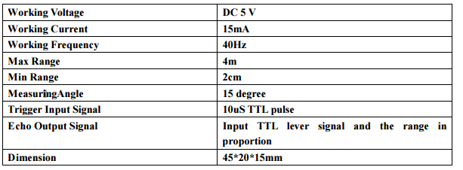

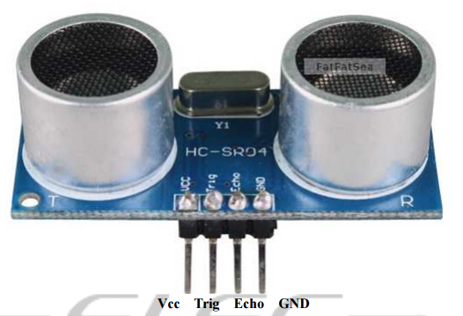

Timing diagram:

The Timing diagram is shown below. You only need to supply a short 10uS pulse to the trigger input to start the ranging, and then the module will send out an 8 cycle burst of ultrasound at 40 kHz and raise its echo. The Echo is a distance object that is pulse width and the range in proportion.

You can calculate the range through the time interval between sending trigger signal and receiving echo signal. Formula: uS / 58 = centimeters or uS / 148 =inch; or: the range = high level time * velocity (340M/S) / 2; we suggest to use over 60ms measurement cycle, in order to prevent trigger signal to the echo signal.

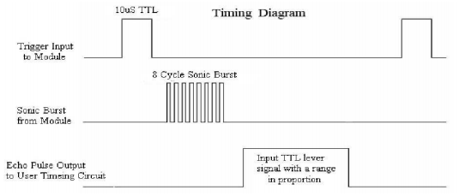

**VOLTAGE DIVIDER**

The HC-SR04 uses TTL (5V) supply voltage and logic levels. The FRDM-KL25Z processor has a 3.3V voltage, but the board provides 5V on the header. The HC-SR04 can use 3.3V levels on the Trig signal, but provides a 5V signal on the Echo pin. To get the signal to the 3.3V level, simple voltage divider with a 21k Ohm and 15k Ohm resistor is used.

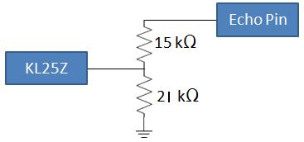

**L293D**

L293D is a Motor Driver IC which allows DC motor to drive on either direction. It is a 16-pin IC which can control a set of two DC motors simultaneously in any direction. It means that you can control about two DC motors with one L293D IC.

It works on the principle of H-bridge. H-bridge is a circuit which allows the voltage to be flown in either direction. As the Voltage need to change its direction for being able to rotate the motor in clockwise or anticlockwise direction. Hence, H-bridge IC are ideal for driving a DC motor.

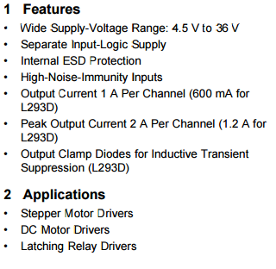

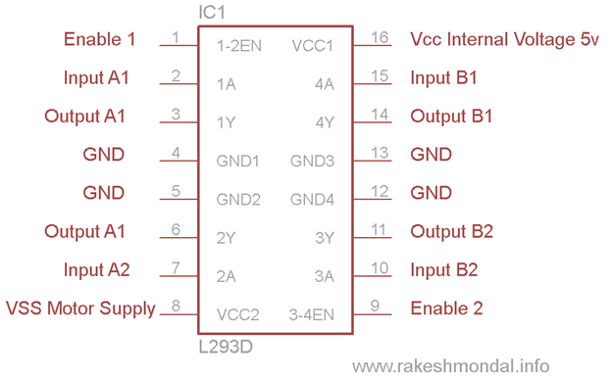

**HC-05 Bluetooth**

HC-05 is a serial port module which makes it very easy to use. In the pin configuration of HC-05, there are total 6 but we are using only 4 middle ones for our set-up.

1. Connect VCC with VCC of microcontroller.
2. Connect GND with any GND of KL25z
3. Connect Rx pin with Tx of kl25z
4. Connect Tx pin with Rx of kl25z.

HC‐05 module is designed for transparent wireless serial connection setup. Serial port Bluetooth module is fully qualified Bluetooth V2.0+EDR (Enhanced Data Rate) 3Mbps Modulation with complete 2.4GHz radio transceiver and baseband. It uses CSR Bluecore 04‐External single chip Bluetooth system with CMOS technology and with AFH (Adaptive Frequency Hopping Feature). It has the footprint as small as 12.7mmx27mm. Hope it will simplify your overall design/development cycle.

Specifications

Hardware features

• Typical ‐80dBm sensitivity.

• Up to +4dBm RF transmit power.

• Low Power 1.8V Operation, 3.3 to 5 V I/O.

• PIO control.

• UART interface with programmable baud rate.

• With integrated antenna.

• With edge connector.

Software features

• Slave default Baud rate: 9600, Data bits: 8, Stop bit:1,Parity:No parity.

• PIO9 and PIO8 can be connected to red and blue led separately. When master and slave are paired, red and blue led blinks 1time/2s in interval, while disconnected only blue led blinks 2times/s. • Auto‐connect to the last device on power as default.

• Permit pairing device to connect as default.

• Auto‐pairing PINCODE:”1234” as default.

• Auto‐reconnect in 30 min when disconnected as a result of beyond the range of connection.

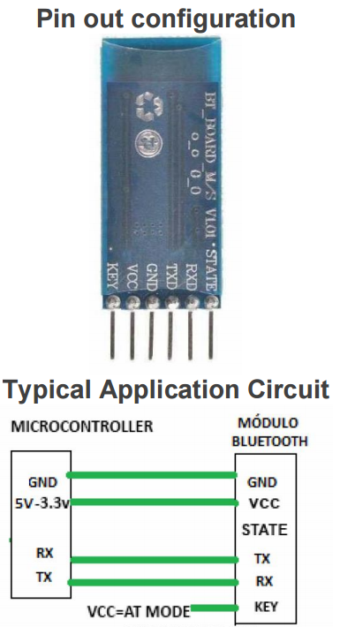

**HARDWARE INTERFACING**

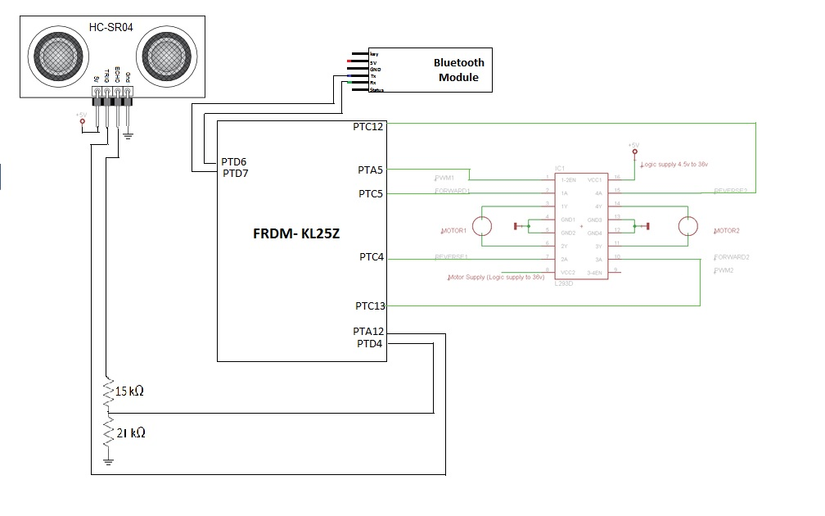

References:

<https://mcuoneclipse.com/2013/01/01/tutorial-ultrasonic-ranging-with-the-freedom-board/>

<http://www.rakeshmondal.info/L293D-Motor-Driver>

<http://www.micropik.com/PDF/HCSR04.pdf>

<http://www.ti.com/lit/ds/symlink/l293.pdf>

<https://en.wikipedia.org/wiki/Ultrasonic_transducer>